Polytechnic University of Puerto Rico

Department of Electrical Engineering

Hato Rey

Module 1 Project COE 4331

Computer Networks Laboratory

November 17, 2016

Schmidt Montilla, Coral Sofia, Student ID: 148830

Professor: Juan Tovar

Table of Contents

Introduction 3

Method 4

Purpose of Each Operating System 4

1. Ubuntu Linux 4

2. Windows Server 2019 4

3. Windows 10 5

Minimum Requirements for Each Operating System 5

1. Ubuntu Linux 5

2. Windows Server 2019 5

3. Windows 10 5

Results: 6

Linux Server (Oracle VirtualBox) 6

Windows Server 2019 (Oracle VirtualBox) 7

Windows 2010 (Oracle VirtualBox) 8

Conclusion 9

References 10

# Introduction

This report explores the purposes and minimum hardware requirements of three widely used operating systems: Ubuntu Linux, Windows Server 2019, and Windows 10. Each operating system is uniquely designed to cater to specific use cases, such as personal computing, server management, and enterprise-level cloud integration. The aim of this analysis is to provide insight into their functionality and performance, helping users select the right platform for their needs. The report also evaluates which operating system is most suitable for particular scenarios, concluding that the best choice depends on the specific tasks and goals. For instance, Ubuntu Linux is ideal for developers and cost-effective server hosting, Windows Server 2019 excels in enterprise resource management and hybrid cloud setups, and Windows 10 offers an intuitive platform for personal and professional productivity.

# Method

To determine the purpose and minimum hardware requirements of Ubuntu Linux, Windows Server 2019, and Windows 10, detailed research was conducted using reputable online sources. These include technical documentation, official blogs, and expert guides, which provide comprehensive information on the design, functionality, and optimal use cases for each operating system.

The choice of the best operating system ultimately depends on the specific use case. Ubuntu Linux is a strong choice for developers and organizations requiring a cost-effective, secure, and flexible platform for hosting servers or lightweight computing tasks. Windows Server 2019 excels in enterprise-level resource management, virtualization, and hybrid cloud integration, making it ideal for businesses with complex IT needs. Windows 10 is well-suited for personal and professional use, offering seamless, user-friendly experience and robust productivity tools across devices.

## Purpose of Each Operating System

### Ubuntu Linux

Ubuntu is an open-source Linux distribution designed for desktops, servers, and IoT devices. It offers a flexible, secure, and cost-effective platform that appeals to developers and enterprises. Key purposes include:

* + Efficient multitasking and system reliability.
  + Hosting web servers, databases, and cloud-based services.
  + Providing a secure, customizable, and lightweight desktop environment for users and developers.

### Windows Server 2019

Windows Server 2019 is a server-focused operating system designed for hybrid cloud integration and infrastructure modernization. Its key purposes are:

* + Managing enterprise-level applications, virtualization, and cloud resources.
  + Hosting websites, databases, and enterprise solutions like Active Directory.
  + Providing robust security and simplified hybrid cloud integration with Azure.

### Windows 10

Windows 10 is a general-purpose desktop operating system known for its user-friendly interface and integration across devices. Its purposes include:

* + Enhancing productivity with tools like Microsoft Edge, Cortana, and virtual desktops.
  + Ensuring comprehensive security with features like Windows Defender and biometric authentication.
  + Enabling a consistent platform for personal and professional use, adaptable to various work styles.

## Minimum Requirements for Each Operating System

### Ubuntu Linux

* + Processor: 2 GHz dual-core processor or higher
  + RAM: 4 GB (physical installation) or 2 GB (virtualized installation)
  + Storage: 25 GB (8.6 GB for minimal installation)
  + GPU: 3D acceleration-capable with at least 256 MB VRAM
  + Display: 1024x768 resolution or higher

### Windows Server 2019

* + Processor: 1.4 GHz 64-bit processor with support for NX, DEP, and SLAT
  + RAM: 512 MB minimum (for Server Core); 2 GB minimum (for Desktop Experience)
  + Storage: 32 GB minimum (more for GUI installations)
  + Network: Gigabit Ethernet adapter

### Windows 10

* + Processor: 1 GHz or faster with at least 2 cores on a 64-bit compatible processor
  + RAM: 4 GB
  + Storage: 64 GB or larger
  + Graphics: DirectX 9 or later with WDDM 1.0 driver
  + Display: 9" screen or larger with 720p resolution

# Results:

## Linux Server (Oracle VirtualBox)

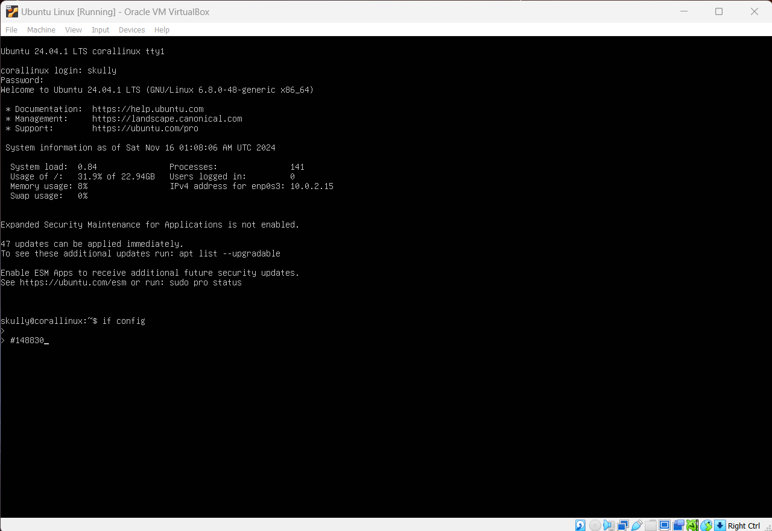

## Windows Server 2019 (Oracle VirtualBox)

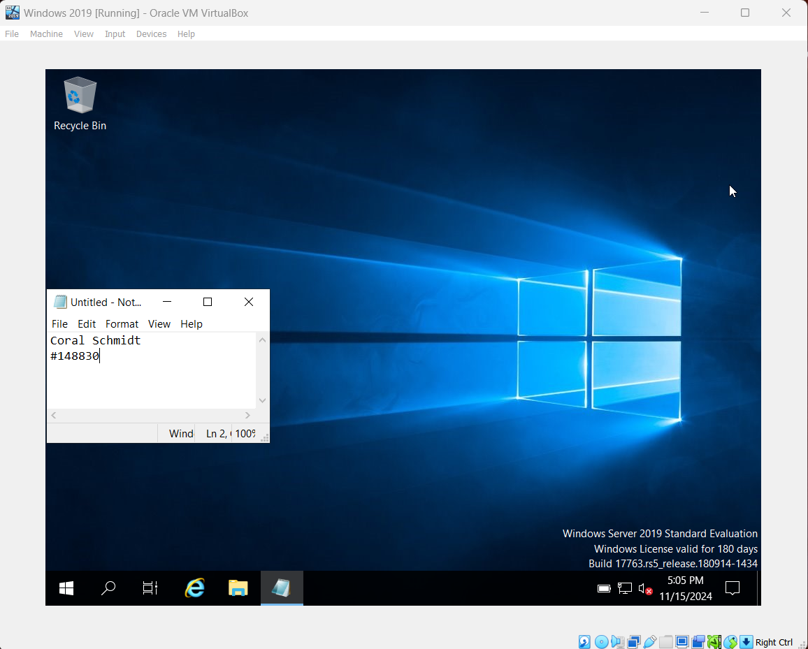

## Windows 2010 (Oracle VirtualBox)

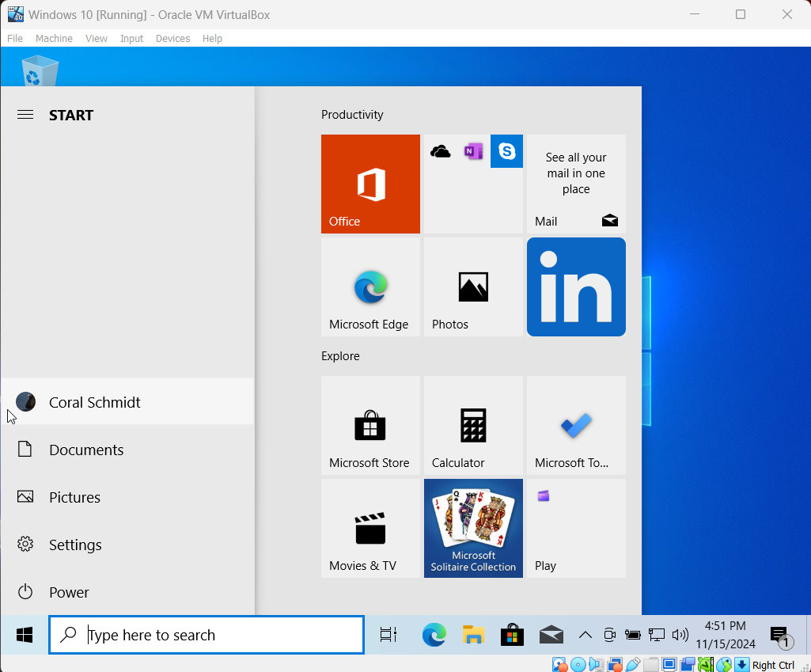

# Conclusion

This report analyzed the purposes and system requirements of Ubuntu Linux, Windows Server 2019, and Windows 10, demonstrating their suitability for different scenarios. Ubuntu Linux stands out as a reliable and cost-effective option for developers and businesses needing a secure server platform. Windows Server 2019 offers advanced features like Active Directory and hybrid cloud integration, catering to enterprise-level IT environments. Windows 10 provides a user-friendly interface, strong productivity tools, and enhanced security, making it a practical choice for both personal and professional use. The decision on which operating system to recommend depends on the user's goals, as each excels in specific domains, ensuring an optimal experience when matched with its intended purpose.

# References

[1] GeeksforGeeks, “What is Linux Operating System,” *GeeksforGeeks*, Jan. 2020, doi: https://doi.org/10124454.m3u8. Available: <https://www.geeksforgeeks.org/introduction-to-linux-operating-system/>. [Accessed: Nov. 16, 2024]

[2] “Installation/SystemRequirements - Community Help Wiki,” *Ubuntu.com*, 2024. Available: <https://help.ubuntu.com/community/Installation/SystemRequirements>. [Accessed: Nov. 16, 2024]

‌ [3] “Guide: How to Install Windows Server 2019 in a Virtual Machine - Petri IT Knowledgebase,” *Petri IT Knowledgebase*, May 11, 2021. Available: <https://petri.com/how-to-install-windows-server-2019-in-a-virtual-machine/>. [Accessed: Nov. 16, 2024]

‌[4] M. Windows, “Everything you need to know about Windows Server 2019 - Part 1 - Microsoft Windows Server Blog,” *Microsoft Windows Server Blog*, Aug. 15, 2018. Available: <https://www.microsoft.com/en-us/windows-server/blog/2018/08/15/everything-you-need-to-know-about-windows-server-2019-part-1/>. [Accessed: Nov. 16, 2024]

‌[5] GeeksforGeeks, “Everything You Need to Know About Windows 10,” *GeeksforGeeks*, Nov. 2024, doi: https://doi.org/10449659586/Start-Menu-660. Available: <https://www.geeksforgeeks.org/all-about-windows-10/>. [Accessed: Nov. 16, 2024]

‌[6] “Why you should upgrade to Windows 10 - Microsoft Support,” *Microsoft.com*, 2024. Available: <https://support.microsoft.com/en-us/windows/why-you-should-upgrade-to-windows-10-fa938f9a-749a-ebb1-2c39-ddd815414b21>. [Accessed: Nov. 16, 2024]

‌

‌